**CSA1086 - Software Engineering**

GitHub File Pushing

STEP 1: Type git init



STEP 2: Create a repo in git hub

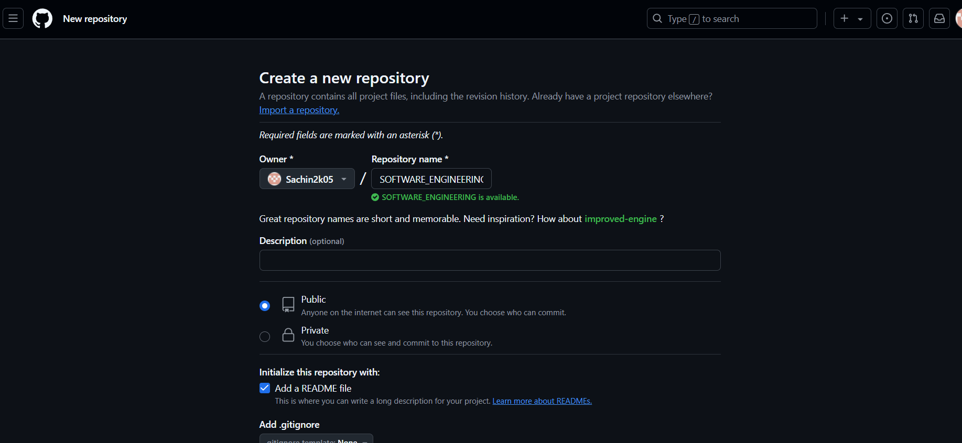

STEP 3: type git status

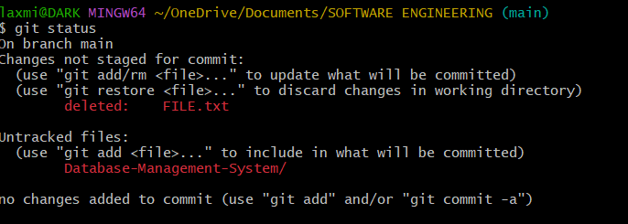

STEP 4: Add the file to ready status



STEP 6: Commit the status

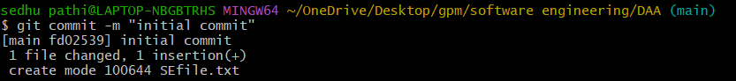

STEP 6: Check the origin



STEP 7: Push the file into main branch

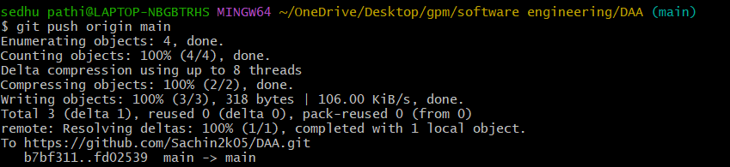

STEP 8:Check the repository for the file

